Leading
Health
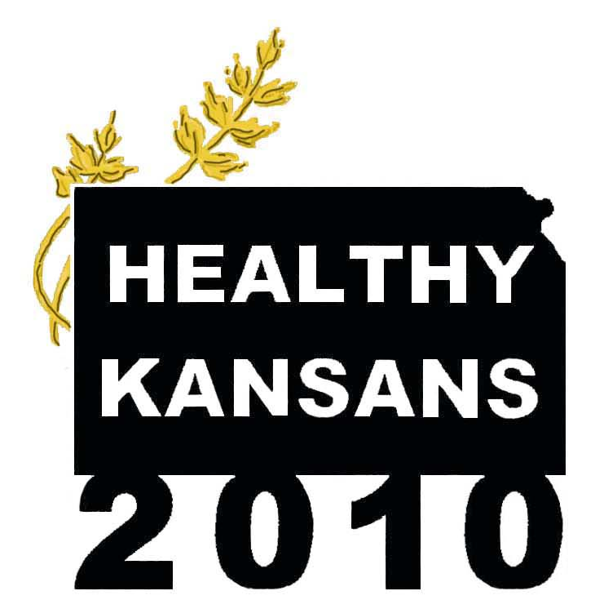
Indicators

Draft Date: May 12, 2005

Notice to Steering Committee Members: Please let us know if you have additions or corrections to the content.

Please submit feedback to Connie Satzler at csatzler@kansas.net or (785) 587-0151.
Table of Contents

Introduction 1
Demographic Profile 2
Physical Activity: Data Profile 4
Physical Activity: Issues and Actions 5
Overweight and Obesity: Data Profile 6
Overweight and Obesity: Issues and Actions 7
Tobacco Use: Data Profile 8
Tobacco Use: Issues and Actions 9
Substance Abuse: Data Profile 10
Substance Abuse: Issues and Actions 11
Responsible Sexual Behavior: Data Profile 12
Responsible Sexual Behavior (HIV/STD): Issues and Actions 13
Mental Health: Data Profile 14
Mental Health: Issues and Actions 15
Injury and Violence: Data Profile 16
Injury and Violence: Issues and Actions 17
Environmental Quality: Data Profile 18
Environmental Quality: Issues and Actions 19
Immunization: Data Profile 20
Immunization: Issues and Actions 21
Access to Care: Data Profile 22
Access to Care: Issues and Actions 23

Introduction
Figure 1

In Healthy People 2010, the Leading Health Indicators reflect major public health concerns in the United States and were chosen based on their ability to motivate action, the availability of data to measure their progress, and their relevance as broad public health issues. These Leading Health Indicators have been adopted by the Healthy Kansans 2010 process as (1) the lens through which to review a broad collection of state plans and initiatives and (2) the indicators by which to monitor change in the health of Kansans as strategies are adopted. (See Figure 1.)

The Leading Health Indicators are
- Physical activity
- Overweight and obesity
- Tobacco use
- Substance abuse
- Responsible sexual behavior
- Mental health
- Injury and violence
- Environmental quality
- Immunization
- Access to health care

For each Leading Health Indicator, we have provided a Data Profile and Issues and Actions Brief. The Data Profile highlights Kansas-specific data for key objectives. One to three Healthy People 2010 objectives were selected to measure progress for each Leading Health Indicator. These objectives are only indicators and do not represent all the objectives in Healthy People 2010. Kansas data is not available for some objectives. In these instances, proxy Kansas-specific measures or national data is substituted.

The Issues and Actions Brief highlights strengths, gaps, needs, opportunities, resources, and key partners in Kansas for each Leading Health Indicator.

First, a brief demographic profile of Kansas is presented as context.

Demographic Profile
1920
1960
2000
Figure 2

The estimated 2004 Kansas population is 2,735,502, which represents 0.9% of the U.S. 2004 population of 293,655,404. The Kansas population has represented a small and slightly decreasing proportion of the U.S. population for several decades (1.9% in 1900 and 1.3% in 1950).

Also during the past several decades in Kansas, rural areas have become more sparsely populated while urban areas have become more densely populated. The population continues to migrate towards metropolitan (Wichita, Topeka, Kansas City) and micropolitan (e.g., Garden City) areas and away from outlying rural areas. (See Figure 2.)

Some of the data resources report rural/urban statistics by grouping counties into the following peer groups. (See Table 1 and Figure 3.) Note that 31 out of the 105 Kansas counties are Frontier counties, with a population density of less than 6 persons per square mile. Two-thirds of Kansas counties are either frontier or rural, but these counties represent less than 15% of the state’s population.

Table 1. Population Density Peer Groups
Density Group | Definition  (Population per square mile) | Number of Counties | Percent of 2000 Kansas Population
Frontier | < 6.0 persons/sq. mi. | 31 | 3.7%
Rural | 6.0 – 19.9 persons/sq. mi. | 38 | 10.8%
Dense Rural | 20.0 – 39.9 persons/sq. mi. | 19 | 16.1%
Semi-Urban | 40.0 – 149.9 persons/sq. mi. | 12 | 19.9%
Urban | 150.0 + persons/sq. mi. | 5 | 49.5%

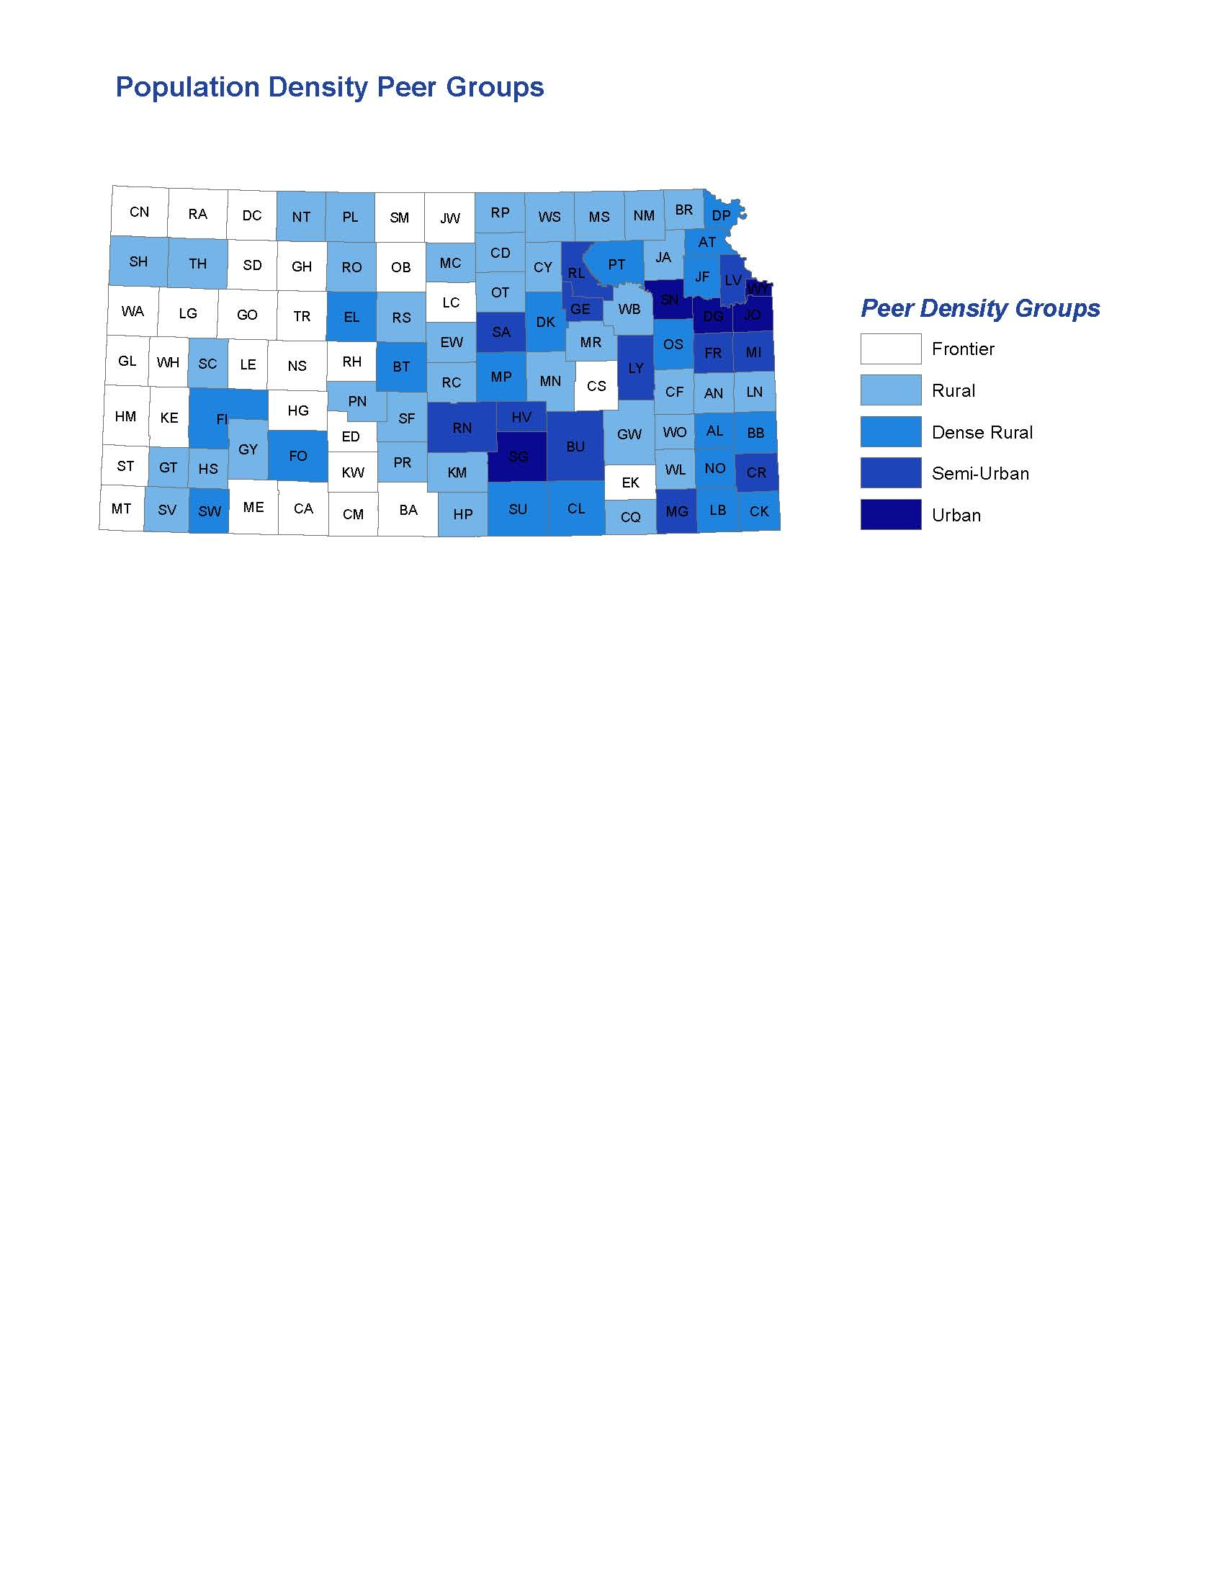
Figure 3

Compared to the U.S., a smaller proportion of the Kansas population is of a minority race or Hispanic ethnicity. Hispanics represent the largest minority group in Kansas (8% in 2003), while African Americans represent the largest racial minority (6% in 2003). (See Figure 4.) Racial and ethnic minorities represent a growing segment of the Kansas population. In 1980, 9.5% of Kansans were part of a racial or ethnic minority group (defined as a non-white race or Hispanic ethnicity), compared to 18% in 2003. (See Figure 5.) While the greatest numbers of the minority population reside in urban areas (particularly African Americans), minority populations have been increasing in both rural and urban counties in recent years.
Figure 4
Note: Racial data represents Non-Hispanic population.
Figure 5

Kansas has a median age of 35.2 years (2000), which is nearly identical to the U.S. median age of 35.3 years (2000). Kansas has slightly higher proportions of young and elderly and slightly lower proportions of working-age adults compared to the U.S. population. Comparing the Kansas White Non-Hispanic and minority populations, the minority population is younger. (See Figures 6 and 7.)

Physical Activity: Data Profile

Physical Activity: Issues and Actions

Strengths
- Multiple initiatives and activities at state and community level
- Funding available for targeted projects through a variety of federal agencies and private foundations
Gaps
- Kansans are not meeting the daily requirements for physical activity and are becoming increasingly sedentary
- Lack of state plan and human resources to coordinate activities at the state level
- No ongoing, dedicated funding
- Lack of proven “best” practices, limited promising practices for change at the population level
- Need improved data monitoring (e.g., at intervention level, for children and adolescents)
- Need improved environmental support (e.g., lighted sidewalks, community design, workplace design)
Opportunities
- Implement related, recommended interventions in CDC’s Guide to Community Preventive Services
- Potential for environmental change
- Potential to educate Kansans on link between sedentary lifestyle and health, how to incorporate physical activity into daily routines
State Resources
- Kansas Department of Health and Environment
  - Office of Health Promotion: Aid-to-Local (e.g., Chronic Disease Risk Reduction grants), Coordinated School Health Project
  - Bureau for Children, Youth, and Families: Incorporated into state Maternal Child Health plan
- Kansas Department of Education: Coordinated School Health, Power Panther Pals
- Kansas Council on Fitness
Key Partners
- Sunflower Foundation
- Get Fit Kansas
- Universities
- Local communities
Actions In-Process
- K-CHAMP: Kansas Child Health Assessment and Monitoring Project

Overweight and Obesity: Data Profile

- Obesity* in adults increased 73% in Kansas from 1991 to 2002, mirroring national trends.
- According to the latest Kansas data, over six-in-ten adults are overweight or obese* (BRFSS, 2003).
- Eleven percent of Kansas adolescents in grades 6 through 12 are overweight or obese* (Kansas Tobacco Youth Survey, 2002).

*Notes:

In children and adolescents, overweight or obesity is defined as at or above the sex- and age- specific 95th percentile of Body Mass Index (BMI) based on a preliminary analysis of data used to construct the year 2000 U.S. Growth Charts (provisional data).

In adults, obesity is defined as a BMI of 30 kg/m² or more.

Overweight is defined as a BMI of more than 25 kg/m² and less than 30 kg/m².

Body Mass Index (BMI) is calculated as weight in kilograms (kg) divided by the square of height in meters (m²) (BMI = weight[kg]/height[m²]). To estimate BMI using pounds (lbs) and inches (in), divide weight in pounds by the square of height in inches. Then multiply the resulting number by 704.5 (BMI = weight[lbs]/height[in²] X 704.5).

Overweight and Obesity: Issues and Actions

Strengths
- Many initiatives and activities at state and community level
- Funding available for targeted projects through a variety federal agencies and private foundations
- Increased public awareness of this problem
Gaps
- Kansans are becoming more obese
- Only a small percentage of Kansans are meeting the 5-a-day fruits and vegetables recommendation
- Shortage of registered dieticians
- Lack of surveillance system for children and adolescents
- Health care providers not comfortable counseling patients on weight loss
- Segmented approach; lack of continuity in message and programming
Opportunities
- Implement proven interventions:
  - Increased physical activity
  - Improved diet and nutrition (5-a-day, breastfeeding)
  - Decreased screen time
State Resources
- Kansas Department of Health and Environment
  - Office of Health Promotion: Aid-to-Local (e.g., Chronic Disease Risk Reduction grants), Incorporating primary prevention into state plans for cancer, diabetes, arthritis, and cardiovascular health
  - Bureau for Children, Youth, and Families: WIC, Selected as one of top priorities in state plan
- Kansas Department of Education: Coordinated School Health, Power Panther Pals
- Kansas Department on Aging
- Strong Governor’s agenda
Key Partners
- Kansas Lean 21 Coalition
- Universities: University of Kansas Medical School, K-State Research and Extension
- Kansas Nutrition Network
- Kansas Health Institute
- Local communities
Actions In-Process
- K-CHAMP: Kansas Child Health Assessment and Monitoring Project
- Kansas Health Activity and Nutrition Survey (statewide survey with over-sampling for Hispanic and African American populations)

Tobacco Use: Data Profile
- Nationally, cigarette smoking has decreased in the past decade from 26% to 22%.

- Both Kansas and the U.S. are above the Healthy People 2010 target of 16%.

- In Kansas, rates were slightly higher among males versus females and younger adults versus older adults (Kansas BRFSS, 2003).

- Kansas current smoking rates were higher among persons with lower household income, lower levels of educational attainment, out of work versus employed, and married versus divorced. Those without health insurance reported higher smoking rates than those with health insurance (38% versus 19%, Kansas BRFSS, 2003).

- Twenty-one percent of Kansas adolescents smoke, with smoking increasing with age (Kansas Tobacco Youth Survey, 2002).

Tobacco Use: Issues and Actions

Strengths
- Strong Tobacco Coalition, multiple partners involved with issue
Gaps
- Segmented approach; unable to address the continuum of needs for the population (e.g, prenatal cessation is good, but this falls off after child is born)
- Youth access to tobacco illegal but not enforced; gateway drug for youth; need to educate juvenile justice authorities and retailers
- Lack of statewide workplace, school grounds policies
- Need an ongoing media campaign
- Political influence of tobacco industry
Opportunities
- Research shows a combination of therapies are needed for success
- Tobacco use control program tied to CDC best practices
- Doctor referral
State Resources
- Kansas Department of Health and Environment
  - Office of Health Promotion: Tobacco Use Prevention
  - Bureau for Children, Youth, and Families: Incorporated into state Maternal Child Health plan, Healthy Start Home Visitors
  - Office of Local and Rural Health: Public health nurse liaison to local communities
- Kansas Department of Education
- Social and Rehabilitation Services
Key Partners
- Tobacco Free Kansas Coalition
- American Lung Association
- American Cancer Association
- American Heart Association
- Kansas Academy of Family Physicians
- Local health departments, community-based organizations
Actions In-Process
- Quitline
- Youth Tobacco Survey, Adult Tobacco Survey

Substance Abuse: Data Profile
- In 2002, 16% of both Kansas and U.S. adults reported binge drinking on at least one occasion in the past 30 days.

- Both the state and the national rate are well above the Healthy People 2010 goal of 6%.

- Reported binge drinking decreased significantly with age (Kansas BRFSS, 2003).

- Males are more than four times to report binge drinking than females.

- Binge drinking rates were higher among respondents with lower household income versus higher household income, never married versus married or divorced, and smokers versus non-smokers (Kansas BRFSS, 2003).

- According to the Kansas Communities That Care Survey Youth Survey (2003):
  - 32% of 6th, 8th, 10th, and 12th graders reported alcohol use at least once in the past 30 days
  - 9.5% of 6th, 8th, 10th, and 12th graders reported marijuana use at least once in the past 30 days

Substance Abuse: Issues and Actions

Strengths
- Committed, passionate prevention and treatment workforce
- Promotion and training in implementation of evidence-based practices
- Outcomes-based planning based on rich data set to guide decisions for prevention and treatment services
- Strong partnerships/coalitions across state
Gaps
- Stigma continues
- Need to market treatment as well as prevention; people don’t know the system well
- Level funding for past several years resulting in reimbursement rates not competitive with other funding streams
- Recruitment and leadership development in younger workforce that will take the place of the aging workforce
- Limited bed capacity for residential services
- Need to insure evidence-based practices on treatment side as well as have on prevention side
- Case management; keeping clients retained in services
Opportunities
- Look for cost savings in system so can raise reimbursement rates to more competitive levels
- Promote, elevate awareness of recovery
- Help providers and consumers understand their role in shaping policy
- Increase focus on screening and assessment in collateral systems
- Increase resources to support family services and other ancillary services
State Resources
- Kansas Department of Social and Rehabilitation Services
- Juvenile Justice Authority
- Kansas Department of Corrections
- Kansas Department of Health and Environment
- Kansas Department of Education
- Legislators
Key Partners
- Provider association
Actions In-Process
- Promoting recovery; recovery conference
- Beginning in-depth state needs assessment
- Promoting evidence-based practices
- Implementing workforce development efforts

Responsible Sexual Behavior: Data Profile

- Data for adolescent sexual behavior in Kansas is not available at this time.

- Nationally in 2003, 88% of adolescents in grades 9 through 12 reported responsible sexual behavior. This includes those adolescents who abstained as well as those who were sexually active but used a condom at the last intercourse.

- Among sexually active unmarried Kansas women of reproductive age (18 to 44 years), 36% reported condom use by partners, which was below the Healthy People 2010 target of 50%.

Responsible Sexual Behavior (HIV/STD): Issues and Actions

Strengths
- Integrated and linked continuum of prevention and care services
- Community based organizations
Gaps
- The HIV/STD programs prevention programs are suffering from funding reductions that have been ongoing since 2002.
- A concentrated effort to reduce the rates of mother to child transmission of HIV is needed.
Opportunities
- Relative to attaining goals, Kansas is a low incidence state for HIV disease, gonorrhea, chlamydia and syphilis.
- Trends tend to follow larger urban areas of the country with a delay of a few years.
- Increasing syphilis rates can be anticipated due to changing nature of behavioral transmission.
- Movement of HIV demographically toward minorities and women with higher rates of heterosexual transmission is occurring.
- Effective interventions must be supported.
State Resources
- Kansas Department of Health and Environment, Bureau of Epidemiology and Disease Prevention
Centers for Disease Control and Prevention
HIV Prevention State $218,311; Federal $1,807,424
STD Program State $482,520; Federal $ 869,030
Surveillance Federal $ 145,187
Health Resources And Services Administration
Ryan White Title II State $2,000,000 + Federal $3,130,712

- Kansas Department of Education, Bureau for Children, Youth and Families, Family Planning Program
Key Partners
- Local health departments
- Private providers
- Community-based organizations
Actions In-Process
- Integration with Tuberculosis program
- Incorporation of technology-based outcome monitoring systems
- Implementation of formal behavioral science-based interventions

Mental Health: Data Profile

- In 1997, 23% of U.S. adults with recognized depression received treatment. This is well below the Healthy People 2010 target of 50%. Kansas data and more recent U.S. data are not available at this time.
- In 2001, 7.5% of Kansas adults reported feeling sad, blue, or depressed 14 or more days in the past month.

Mental Health: Issues and Actions

Strengths
- Progression of development services has come through thoughtful process involving legislators, consumers, advocates, and providers
- Focus on most vulnerable; resources are targeted at most at-risk
- Solid community mental health system; one of least fragmented mental health systems in the country
- Strong collaboration and partnerships between stakeholders in the state
Gaps
- Approaching a problem of having enough inpatient beds
- Funding limitations
  - Dependence on Medicaid and Medical
  - Separate and distinct funding streams
  - Difficult to incorporate incentives to try new interventions
  - Mental health bearing some of substance abuse under-funding burden
- Mental health issues in aging population
- Need to better address “every day” mental health needs (e.g., periods of depression)
Opportunities
- Current administrative climate is more open to making necessary system changes
- Fund quality practice models with proven effectiveness
- Promote full participation in community life
- Encourage better collaboration between state departments
State Resources
- Kansas Department of Social and Rehabilitation Services
Key Partners
- Association of Community Mental Health Centers
- National Alliance for the Mentally Ill (NAMI)
- Keys for Networking
- Consumer-run organizations
- Universities
Actions In-Process
- Federal initiative: Transformation Grant

Injury and Violence: Data Profile
- The Kansas age-adjusted homicide rate is below the national rate (4.6 versus 6.1 for 2002) but above the Healthy People 2010 target of 3.2 homicides per 100,000 population.

- The African American homicide rate is more than 7 times the rate for whites (2003). The rate for Whites is slightly below the Healthy People 2010 target.

- The homicide rate for males is more than twice as high as the rate for females.

- The Kansas motor vehicle age-adjusted death rate is above the U.S. rate (19.7 versus 15.2 in 2002). Both are above the Healthy People 2010 target of 9.2 deaths per 100,000 population.

- In Kansas, males are approximately twice as likely to die in motor vehicle crashes.

Injury and Violence: Issues and Actions

Strengths
- Kansans have access to passenger safety services through Kansas Department of Transportation’s Kansas Safety Belt education office
- More people are buckling up in Kansas
- Community involvement with child safety
Gaps
- Enforcement of safety belt laws in rural areas
- Improperly restrained children in some population groups (special needs, older children)
- Children unprotected related to other child safety issues (bike helmets, working smoke detector, gun locks)
- Better abuse, violence prevention
- E-coded hospital discharge data
Opportunities
- Primary seat belt laws, enforcement
- Public education of booster seat safety, other child safety issues
- Safety education in conjunction with home visits (elderly, disabled, and children)
- Train law enforcement, court system, and care takers for prevention of violence against persons with disabilities
State Resources
- Kansas Department of Health and Environment
  - Office of Health Promotion: Kansas SAFE Kids
  - Bureau for Children, Youth, and Families: Incorporated in state plan
- Kansas Department of Transportation
- Kansas Bureau of Investigation
- Kansas Attorney General’s Office
- Kansas Highway Patrol
Key Partners
- Local communities, coalitions
- Kansas SAFE Kids
- Kansas Coalition on Sexual and Domestic Violence
Actions In-Process

Environmental Quality: Data Profile
- In 2000, 54% of U.S. nonsmokers were exposed to environmental tobacco smoke. This is above the Healthy People 2010 target of 45%.

- Kansas data matching the environmental tobacco smoke indicator is not readily available.

- According to the Kansas Adult Tobacco Survey (2002-2003), 16% of employed Kansas adults working indoors most of the time reported that someone had smoked in their work area within the past 7 days.

- According to the EPA Aerometric Information Retrieval System, 0% of the Kansas population is exposed to ozone above the EPA standard. This meets the Healthy People 2010 objective and is well below the national average of 41% (2001).

Environmental Quality: Issues and Actions

Strengths
- Kansas has no non-attainment areas for criteria air pollutants which include carbon monoxide, sulfur dioxide, nitrogen dioxide, ozone, particulates, and lead.
- KDHE has a good working relationship with Kansas industries
Gaps
- Water quality in Kansas River
- Feedlot runoff
- As urban areas expand an industry grows, the potential for pollution may increase
Opportunities
State Resources
- Kansas Department of Health and Environment
  - Bureau of Waste Management
  - Bureau of Air and Radiation
  - Bureau of Environmental Remediation
  - Bureau of Water
  - Bureau of Environmental Field Services
Key Partners
- Universities
Actions In-Process

Immunization: Data Profile

Immunization: Issues and Actions

Strengths
- Immunization registry has been developed
- Expanded WIC/immunization partnership
- Successful Medicaid immunization outreach; provider education component of Medicaid Outreach
- Kansas parents willing to have children immunized
Gaps
- Kansas’s immunization rates for children two years of age exhibited a decrease every year from 1998 to 2002.
- A CDC study issued in 2003 indicated Kansas had one of the lowest childhood immunization rates in the country.
- Low per capita funding
- Low participation of private providers
- Vaccine supply issues at national level
Opportunities
A 2004 Governor’s Blue Ribbon Immunization Task Force made several recommendations to help in correcting the problem, including:

- Develop a statewide immunization registry.
- Change the age for administration for the fourth dose of DtaP
- Expand immunization reminder systems.
- Expand the current Medicaid immunization outreach project
- Expand the current WIC/KDHE Partnership
- Expand access to childhood immunizations through a child’s medical home

State Resources
- State General Funds in the Kansas immunization program = $1.2 million
- Federal funds = $19 million
Key Partners
- Local health departments
- Private providers
- Private businesses assisting with the Medicaid outreach project
Actions In-Process
- Recommendations of the Governor’s Blue Ribbon Task Force are currently being implemented.

Access to Care: Data Profile

Access to Care: Issues and Actions

Strengths
- Malpractice rates are lower than average
- Adequacy, capacity, and growth of safety net has received support from legislature and governor
- Despite budget crises, state-funded safety net clinics have maintained level funding.
- Various approaches to insure more Kansans (e.g., create pools for small businesses, tax breaks for employers)
- Current level of enthusiasm, attention towards getting health care coverage for uninsured
Gaps
- Recent reports suggest depth of problem (number of uninsured individuals) in Kansas (2001 Insurance study)
- Underinsurance and access issues of “dual-eligible” population (persons with Medicare who qualify for Medicaid)
- Access for undocumented population
- Disparities in access (rural/urban, race/ethnicity, income)
- Lack of sufficient providers and infrastructure for certain populations and segments of the system
- Gaps in coverage of insured population (underinsured)
- Lack of national and state attention on support for prescription drugs (e.g., communities, rather than the state, are providing leadership for prescription drug patient assistance programs)
Opportunities
- Several techniques for growing safety net, including working with the private sector.
- Many communities Health Professional Shortage Area designations, but there are not enough physicians
- HealthWave could serve more Kansas children. More children could qualify, but we don’t have the funds to find them.
- Access always implies access to quality care. Opportunities to improve quality and turn this into savings for the system.
- Further development of trauma system and trauma registry, analysis of trauma registry data
- Developing infrastructure (public and private) for oral health
- Using health information technology to reduce costs
- Benefits from bioterrorism and emergency preparedness activities
State Resources
- Kansas Department of Health and Environment
- Trauma registry, trauma program
- Board of EMS, hospitals, hospital association
Key Partners
- Kansas Medical Society – KS Rural Health Options project
- Kansas Association for the Medically Underserved
- Advisory group
- Kansas Hospital Association, hospitals
Actions In-Process
- Proposal to create Kansas Health Policy Authority
- Kansas Health Consumer Coalition

